Computer Networks

Lab Task #9

Saad Ahmad

20P-0051

**Task**

**Question 1:**

source port number: 60643

destination port number : 80



**Question 2:**

Sequence number (raw): 2682012317

The segment is as a SYN segment because the SYN flag is set to 1.

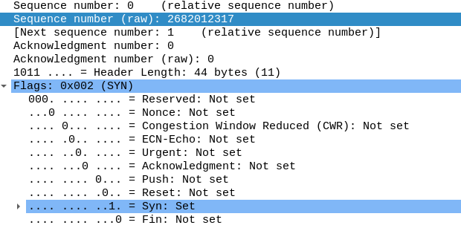

**Question 3:**

The sequence number of the SYNACK segment sent by the server to

the client computer in reply to the SYN is

**Sequence number (raw): 349487776**

The value of the Acknowledgement field in the SYNACK segment is:

**Acknowledgment number (raw): 2682012318**

The server determine that value in such a way that receiver take the sequence number from the sender and increment it by 1 and send it back to the sender as acknowledgement number.

The segment is as a SYN, ACK segment because the SYN, ACK flags are set to 1.

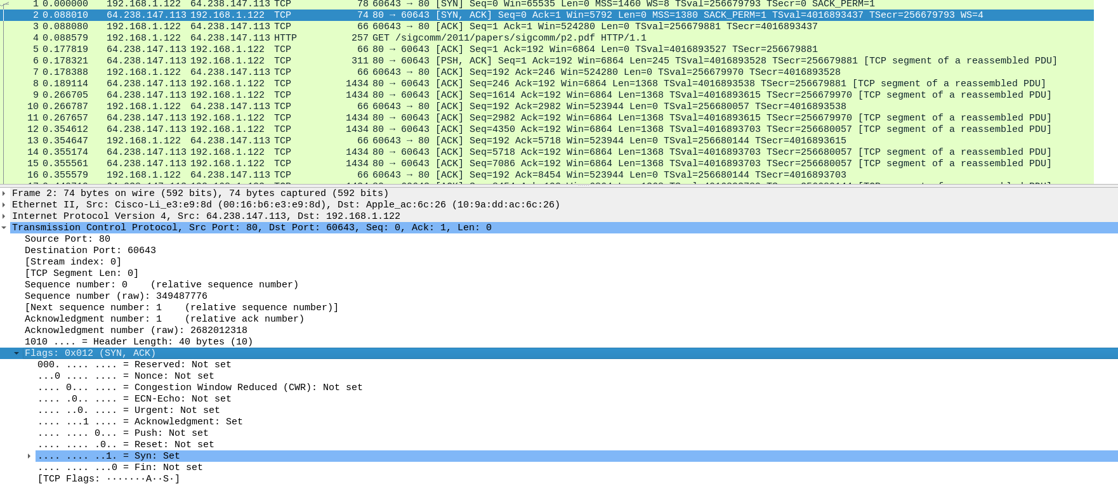

**Question 4:**

Segment 1 length = 191

Segment 2 length = 0

Segment 3 length = 245

Segment 4 length = 0

Segment 5 length = 1368

Segment 6 length = 1368

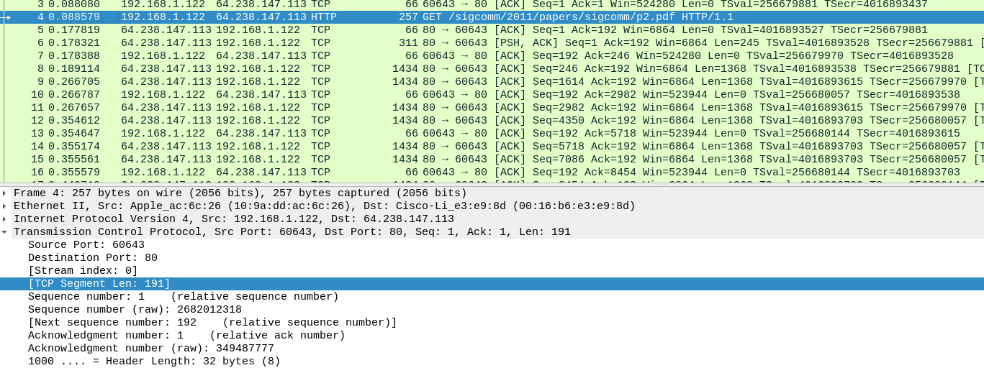

**Question 5:**

No, there are no retransmitted segments in the trace file.